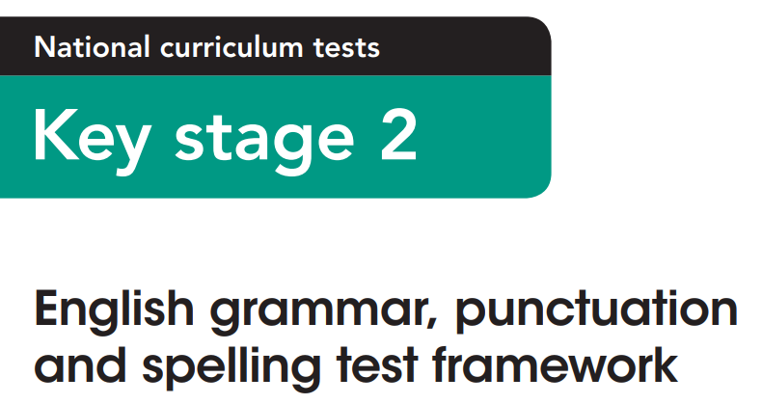

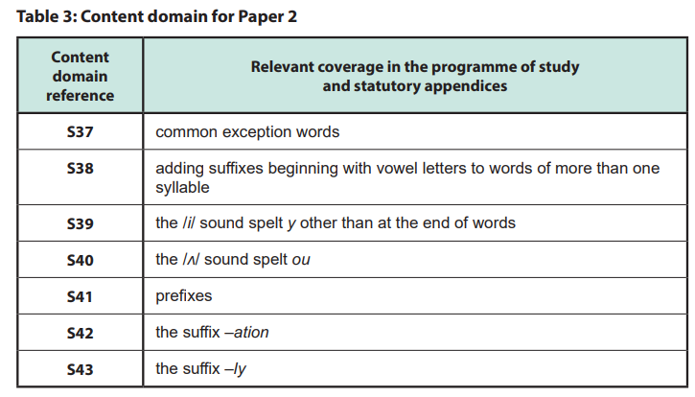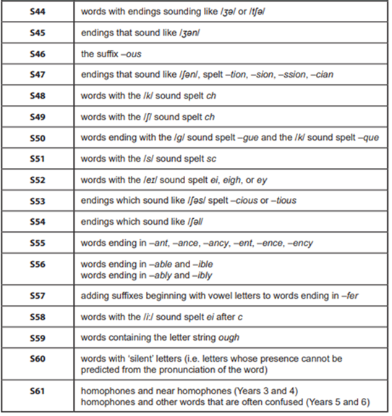

Example spellings for each spelling pattern and rule above:
S37 | S38 | S39 | S40
common exception words (words that don’t follow standard phonetic or spelling rules) | adding suffixes beginning with vowel letters to words of more than one syllable | the /i/ sound spelt y other than at the end of words | the /ʌ/ sound spelt ou
conscience  conscious  controversy  convenience  prejudice  privilege  programme  queue  recognise  recommend  sincerely  signature  sufficient  temperature  thorough  marvellous  mischievous  muscle  neighbour  occupy  opportunity  parliament  yacht  according  communicate | forgetting  beginning  preferred  offering  limited  listening  gardening  considered  remembering  delivered  separated  answered  deciding  admiring  escaping  inviting  hoping  loving  smiling  shouted  puzzling  whispering  developing  interesting  forgetful | gym  myth  pyramid  mystery  lyrics  system  symbol  typical  oxygen  crystal  symptom  synod  syrup  cymbal  cylinder  hymn  crypt  gypsy  physic  physics  mystical  syllable  lynx  syringe  synonym | young  country  touch  double  trouble  couple  cousin  courage  encourage  nourish  flourish  enough  tough  rough  southern  colour  youngish  youngster  toughen  roughen  troubling  touched  courageously  nourishing  flourishing

S41 | S42 | S43 | S44
prefixes | the suffix –ation | the suffix –ly | words with endings sounding like /ʒə/ (-sure / -zure) or /tʃə/ (-ture / -cher)
unhappy  unfair  untidy  uncertain  disagree  dislike  disappear  disconnect  misbehave  mislead  misplace  misspell  replay  rebuild  rewrite  recycle  preheat  prehistoric  prejudge  preprepare  autopilot  autocorrect  superhuman  supermarket  interact | • information  • preparation  • imagination  • creation  • animation  • population  • operation  • sensation  • decoration  • admiration  • celebration  education  exploration  examination  translation  transportation  communication  relaxation  separation  organisation  frustration  observation  location  rotation  hesitation | quickly  slowly  quietly  loudly  happily  sadly  angrily  carefully  carelessly  finally  usually  suddenly  fortunately  unfortunately  certainly  definitely  basically  completely  simply  gently  bravely  cleverly  happily  eagerly  rapidly | measure  treasure  pleasure  leisure  exposure  closure  pressure  fissure  erasure  composure  enclosure  disclosure  seizure  azure  leisurely  censure  assure  reassure  displeasure  leisurewear  brochure  enclosure  ensure  fissure

S44 |  | S45 | S46
words with endings sounding like /ʒə/ (-sure / -zure) or /tʃə/ (-ture / -cher) |  | endings that sound like /ʒən/ (-sion) | the suffix –ous
adventure  creature  picture  furniture  mixture  nature  future  capture  fracture  puncture  structure  feature  texture  sculpture  nurture  manufacture  rapture  signature  literature  departure  temperature  architecture  miniature  pasture  legislature | teacher  catcher  butcher  stretcher  watcher  archer  marcher  dispatcher  pitcher  scratcher  snatcher  bleacher  poacher  launcher  voucher  dispatcher  fletcher  breacher  dispatcher  searcher  researcher  preacher | division  invasion  collision  confusion  explosion  conclusion  decision  revision  erosion  illusion  persuasion  occasion  television  confusion  intrusion  diffusion  cohesion  vision  corrosion  precision  supervision  provision  exclusion  inclusion  persuasion | famous  dangerous  nervous  curious  mysterious  poisonous  adventurous  enormous  jealous  furious  glorious  fabulous  enormous  various  humorous  courageous  serious  marvellous  precious  anxious  victorious  mountainous  hazardous  cautious  generous

S47
endings that sound like /ʃən/, spelt –tion, –sion, –ssion, –cian

action  addition  ambition  attraction  attention  caution  celebration  circulation  collection  communication  competition  connection  correction  creation  decoration  devotion  direction  division  education  election  fiction  fraction  infection  nation  operation | division  invasion  explosion  confusion  collision  erosion  revision  decision  conclusion  illusion  persuasion  occasion  intrusion  diffusion  cohesion  vision  corrosion  supervision  provision  inclusion  exclusion  precision  television  confusion  explosion | discussion  expression  confession  permission  admission  mission  possession  impression  progression  succession  obsession  oppression  aggression  transmission  submission  profession  depression  procession  concession  commission  suppression  compassion  intermission  passion | musician  electrician  magician  politician  optician  beautician  physician  mathematician  technician  dietician  clinician  paediatrician  librarian  magician  academician  statistician  electrician  technician  optician  musician  dietician  beautician  physician  politician  technician

S48 | S49 | S50
words with the /k/ sound spelt ch | words with the /ʃ/ sound spelt ch | words ending with the /g/ sound spelt –gue and the /k/ sound spelt –que
chaos  character  chemist  echo  stomach  school  scheme  anchor  ache  mechanic  orchestra  architect  chemistry  chorus  choir  chrome  chronic  monarch  chrysalis  chlorine  chaos  anchor  chorus | chef  chalet  machine  parachute  brochure  champagne  chute  moustache  charade  chandelier  crochet  chauffeur  brochure  cliché  chenille  pistachio  quiche  echelon  attaché  cachet  charcuterie  chic  chassis  chiffon  chivalry | league  plague  vague  tongue  rogue  fatigue  dialogue  monologue  intrigue  analogue  catalogue  colleague  prologue  epilogue  refuge  morgue  synagogue  harangue  ague  vogue  mange  deluge | antique  unique  mystique  plaque  mosque  cheque  critique  boutique  burlesque  picturesque  opaque  baroque  clique  oblique  physique  torque  grotesque  mystique  cheque  boutique  marquee  masque  boutique  pique  bisque

S51 | S52
words with the /s/ sound spelt sc | words with the /eɪ/ sound spelt ei, eigh, or ey
science  scent  scissors  scene  crescent  discipline  fascinate  muscle  ascend  descent  scenery  scientist  conscious  conscience  adolescent  fluorescent  miscellaneous  adolescent  ascendancy  fascinator  muscular  miscellaneous  adolescent  scenario  sceptic | eight  weight  neighbour  sleigh  reign  vein  beige  freight  reignite  feint  rein  surveillance  veil  eighteen  eighty  reindeer  inveigh  heinous  foreign  beige  reining  weightless  deign  feign  seismic | eight  eighty  eighteen  eighth  weight  weighted  weighting  sleigh  sleighed  neighbour neighbourhood  neighbouring  freight  freighted  inveigh | they  grey  prey  convey  survey  obey  conveyor  surveyor  hey  whey  abeyance  purvey  purveyor  disobey  heyday  conveyance  conveyor-belt  surveyable

S53 |  | S54
endings which sound like /ʃəs/ spelt  –cious or –tious |  | endings which sound like /ʃəl/ (-cial or -tial)
delicious  suspicious  conscious  precious  vicious  gracious  spacious  malicious  ferocious  atrocious  audacious  efficacious  vivacious  tenacious  ungracious  officious  pernicious  precocious  capacious  fallacious  lubricious  mendacious  rapacious  sagacious  veracious | cautious  ambitious  nutritious  infectious  superstitious  repetitious  fictitious  pretentious  contentious  ostentatious expeditious  surreptitious  adventitious  unambitious  facetious | special  official  unofficial  social  financial  commercial  non-commercial  artificial  beneficial  crucial  facial  judicial  judicially  racial  provincial  antisocial  especially  superficial  multiracial  interracial  prejudicial  sacrificial  socialite  artificiality | essential  initial  potential  partial  substantial  confidential  residential  influential  circumstantial  sequential  preferential  existential  experiential  differential  credential  penitential  prudential  torrential  consubstantial  substantiality  initialled  initialling  inconsequential  exponential

S55
words ending in –ant, –ance, –ancy, –ent, –ence, –ency

important  brilliant  assistant  hesitant  tolerant  defiant  pleasant  servant  applicant  immigrant  occupant  significant  dominant  resistant  relevant  constant  vacant  distant  elegant  reluctant  triumphant  abundant  fragrant  jubilant  observant | importance  distance  balance  guidance  entrance  appearance  reliance  performance  tolerance  instance  substance  annoyance  acceptance  resistance  brilliance  defiance  elegance  reluctance  allowance  abundance  ambulance  significance  observance  clearance  attendance | vacancy  hesitancy  brilliancy  expectancy  constancy  buoyancy  relevancy  redundancy  infancy  militancy  malignancy  poignancy  pregnancy  consultancy  vibrancy  legitimacy  discrepancy  tendency  compliancy  persistency  abundancy  elegantancy  dominancy  ascendancy  occupancy | different  excellent  silent  absent  patient  violent  confident  intelligent  dependent  independent  ancient  recent  present  resident  accident  president  efficient  sufficient  frequent  apparent  innocent  crescent  violent  obedient  urgent

S55 |  | S56
words ending in –ant, –ance, –ancy, –ent, –ence, –ency |  | words ending in –able and –ible words ending in –ably and –ibly
silence  absence  patience  confidence  difference  residence  evidence  existence  preference  reference  sequence  defence  offence  innocence  presence  essence  audience  licence • diligence  persistence  competence  convenience  influence  obedience  independence | emergency  agency  urgency  currency  fluency  efficiency  consistency  dependency  independency  tendency  transparency  decency  residency  frequency  potency  delinquency  clemency  complacency  competency  proficiency  resiliency  latency  solvency  ascendancy  malignancy | enjoyable  breakable  washable  manageable  believable  comfortable  dependable  affordable  acceptable  changeable  noticeable  reliable  predictable  renewable  reusable  valuable  considerable  suitable  avoidable  movable  excitable  curable  replaceable  understandable  searchable | believably  unbearably  comfortably  reasonably  understandably  remarkably  reliably  noticeably  changeably  unchangeably  agreeably  disagreeably  enjoyably  enviably  miserably  honourably  memorably  desirably  favourably  unfavourably  admirably  impossibly  sensibly  possibly  predictably

S56 |  | S57 | S58
words ending in –able and –ible words ending in –ably and –ibly |  | adding suffixes beginning with vowel letters to words ending in –fer | words with the /i:/ sound spelt ei after c
possible  impossible  sensible  visible  invisible  terrible  horrible  edible  incredible  responsible  reversible  divisible  flexible  legible  eligible  tangible  gullible  forcible  terrible  admissible  permissible  invincible  destructible  collapsible  reducible | possibly  impossibly  sensibly  insensibly  forcibly  irresistibly  visibly  invisibly  horribly  terribly  incredibly  credibly  indelibly  flexibly  gullibly  legibly  illegibly  tangibly  intangibly  plausibly  implausibly  feasibly  inflexibly  audibly  inaudibly | preferred  preferring  preference  referred  referring  referral  transferring  transferred  conferring  inferred  inferring  differed  differing  offering  offered  sufferer  suffering  suffered  proffering  proffered  interfering  interfered  circumference  conference  difference | ceiling  receive  receipt  conceit  deceit  perceive  conceited  deceitful  receiving  received  perceiving  perceived  ceilinged  conceiving  conceived  receiptless  receiver  conceiver  conceivably  perceivable  deceitfully  conceitedly  receivable  conceitedness  perceiver

S59 | S60 | S61
words containing the letter string ough | words with ‘silent’ letters | homophones and near homophones  (Years 3 and 4) | homophones and other words that are often confused  (Years 5 and 6)
though  although  thought  through  thorough  borough  rough  tough  enough  cough  trough  plough  bough  drought  sought  brought  bought  fought  ought  nought  thoroughfare  dough  doughnut  throughout  thoughtless | knight  knock  knee  knowledge  write  wrong  wreck  wren  lamb  comb  climb  debt  doubt  island  listen  whistle  castle  hustle  soften  often  answer  sign  gnaw  foreign  autumn | hear – here  there – their – they’re  your – you’re  to – two – too  bare – bear  one – won  sun – son  see – sea  be – bee  night – knight  quite – quiet  hole – whole  mail – male  weather – whether  whose – who’s  brake – break  grate – great  heel – heal – he’ll  meet – meat  missed – mist  rain – rein – reign  allowed – aloud  peace – piece  sale – sail  knot – not | accept  except  affect  effect  passed  past  proceed  precede  practise  practice  advice  advise  licence  license  assent  ascent  compliment  complement  principal  principle  prophecy  prophesy  stationery  stationary  father  farther

